**VISVESVARAYA TECHNOLOGICAL UNIVERSITY, BELGAUM 590014**

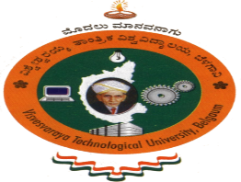

Mobile Application DevelopmentReport on

**“Feeder: Course Feedback and Survey App”**

By

ANUSHREE (1BM14CS021) CHARISHMA B(1BM14CS031)

ABHIJEET CHAUHAN (1BM14CS003) HEMANTH P (1BM14CS121)

Under the Guidance of

**Prof. Selva kumar S**

Assistant Professor, Department of CSE

BMS College of Engineering

Mobile Application Development carried out at



Department of Computer Science and Engineering

BMS College of Engineering

(Autonomous college under VTU)

P.O. Box No.: 1908, Bull Temple Road, Bangalore-560 019

2016-2017

**BMS College of EngineerinG**

**DEPARTMENT OF COMPUTER SCIENCE AND ENGINEERING**



***CERTIFICATE***

This is to certify that the mobile application development titled “**Feeder: Course Feedback and Survey App**” has been carried out by ANUSHREE (1BM14CS021), CHARISHMA B (1BM14CS031), ABHIJEET CHAUHAN (1BM14CS003), HEMANTH P(1BM14CS121) during the academic year 2016-2017.

Signature of the guide

**Prof. Selva kumar S**

Assistant Professor

Department of Computer Science and Engineering

BMS College of Engineering, Bangalore

**BMS College of EngineerinG**

**DEPARTMENT OF COMPUTER SCIENCE AND ENGINEERING**



***DECALARATION***

We, ANUSHREE (1BM14CS021), CHARISHMA B (1BM14CS031), ABHIJEET CHAUHAN (1BM14CS003), HEMANTH P(1BM14CS121) , students of 6th Semester, B.E, Department of Computer Science and Engineering, BMS College of Engineering, Bangalore, hereby declare that, this mobile application development work entitled " **Feeder: Course Feedback and Survey App** " has been carried out by us under the guidance of Prof. Selva kumar S, Assistant Professor, Department of CSE, BMS College of Engineering, Bangalore during the academic semester Jan-April 2017.

We also declare that to the best of our knowledge and belief, the development reported here is not from part of any other report by any other students.

Signature

ANUSHREE (1BM14CS021)

CHARISHMA B (1BM14CS031)

ABHIJEET CHAUHAN(1BM14CS003)

HEMANTH P (1BM14CS121)

**1. Introduction**

**Feeder: Course Feedback and Survey App**

This mobile application is a portal, where the faculty can add events, which are shown as upcoming tasks in the form of deadlines on the student’s dashboard in a highlighted date format, facilitated by caldroid component. The student is allowed to respond to the rating bar type questions. The responses get stored in the local database (Shared Preferences), taken to the web based Django panel via a Retrofit Interface (Gson Model).

**2. Functionalities included in the app**

**STUDENT**

* Login : A registered student can login by providing username (his/her roll no.) and password.
* View upcoming events: Any registered student can view the pending feedbacks by tapping on the caldroid date cell.
* Respond to the given feedbacks :When the student clicks on a particular feedback, he can respond to the rating bar type questions.
* Use toolbar utilities :A drawer contains various options like logout option, switching accounts, etc.

**ADMIN**

* Login : The faculty can login with his/her registered credentials to use the Django panel.
* Adding Courses/Feedbacks : New courses and their corresponding feedbacks can be added by the admin.
* Student Enrollment : Admin can enroll the students into a particular course of the semester.
* Manipulating feedbacks: Admin can add/delete/modify the questions of a particular feedback.
* View Responses : Administrator can view the student responses given to a particular feedback by going to response section.

After responding to the feedback, the student is taken back to his/her dashboard on pressing the back button. Again, any date can be tapped and the related events can be viewed/responded to.

On logging out, the local shared preference variable gets destroyed and the responses get stored in the database.

**3. Database**

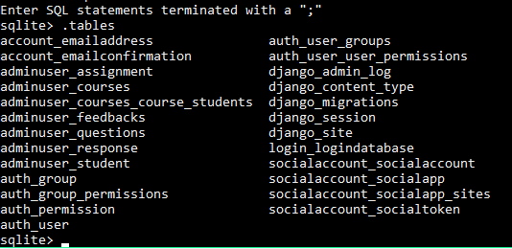

**4. UI Screenshots**

**STUDENT**

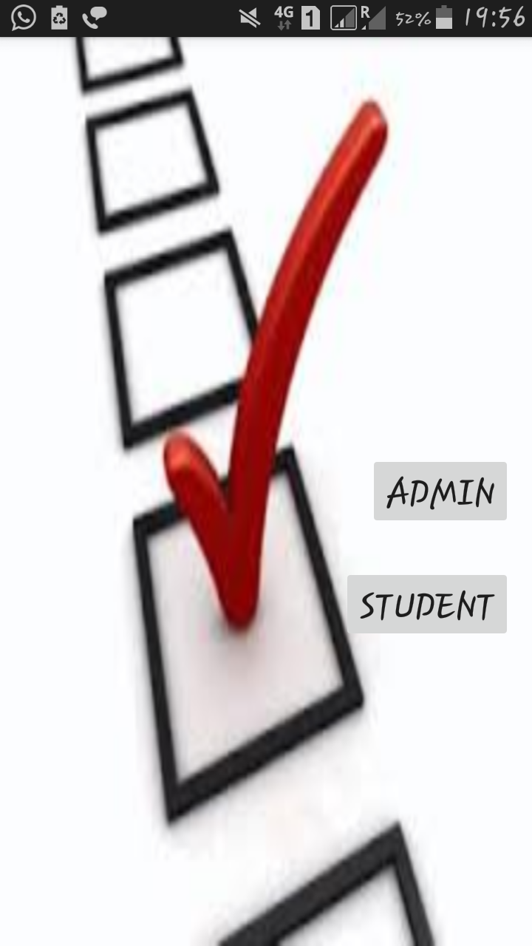 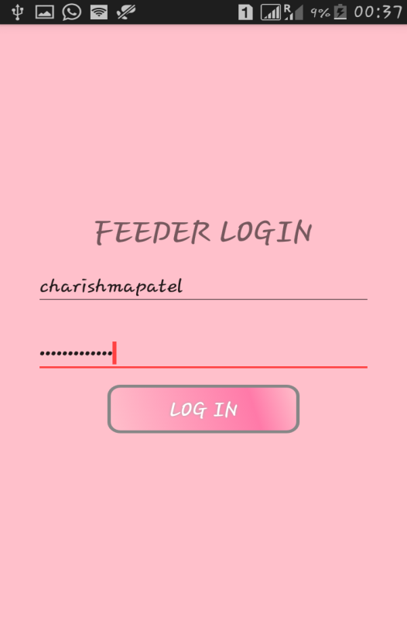

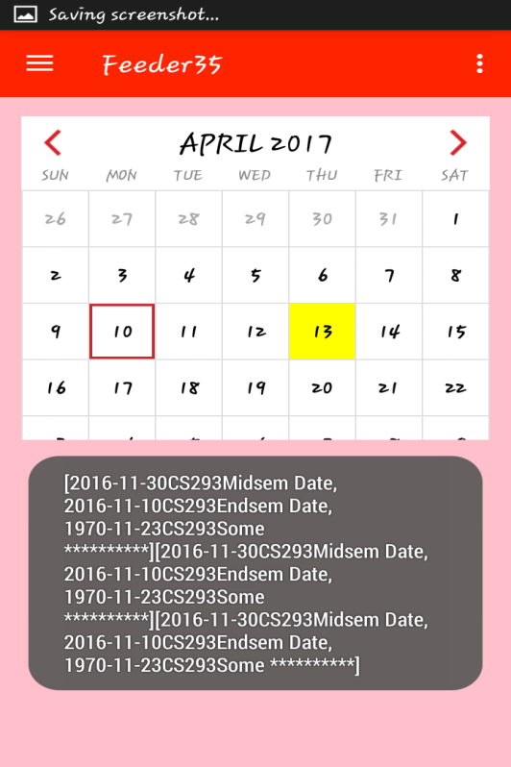 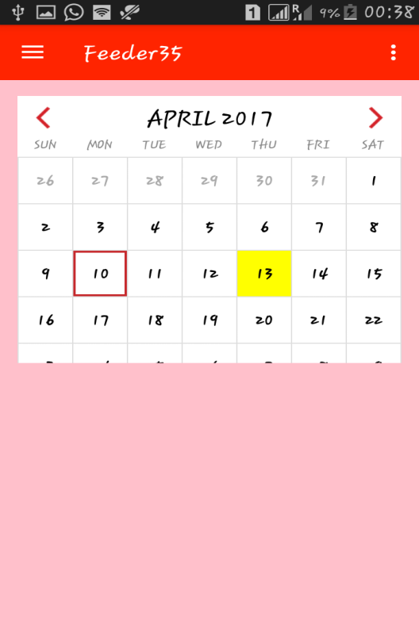

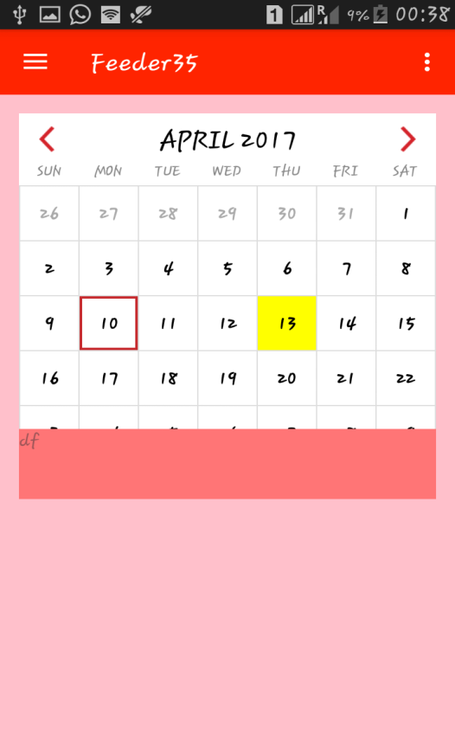 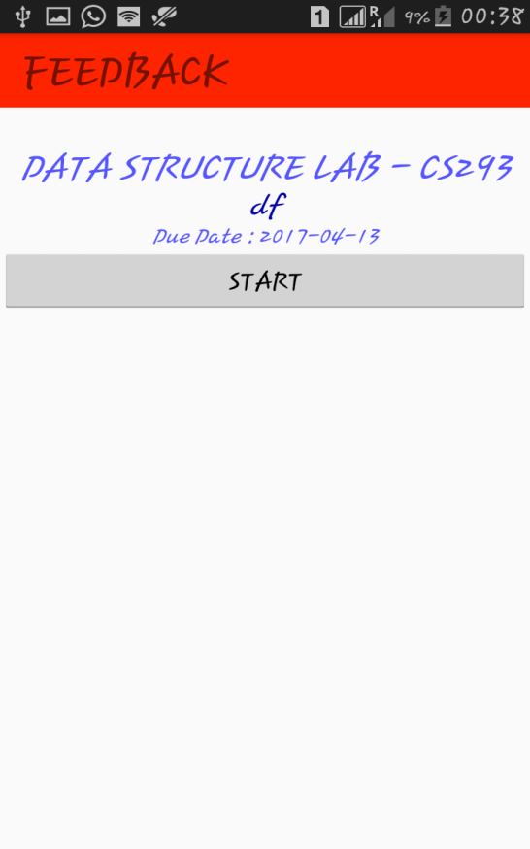

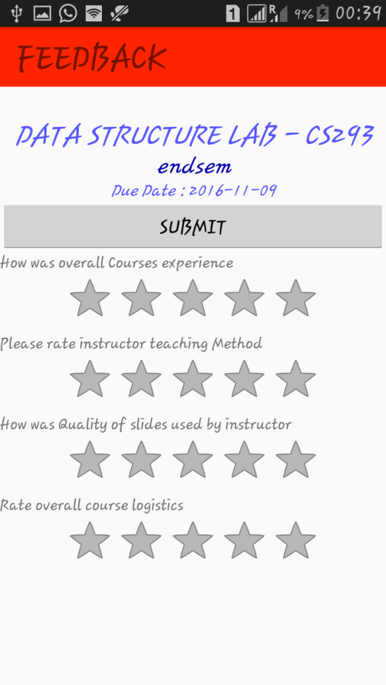 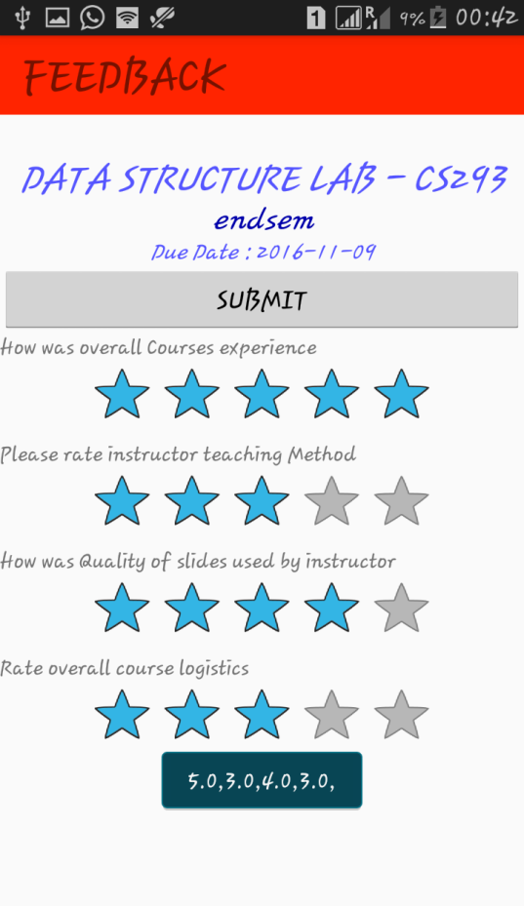

 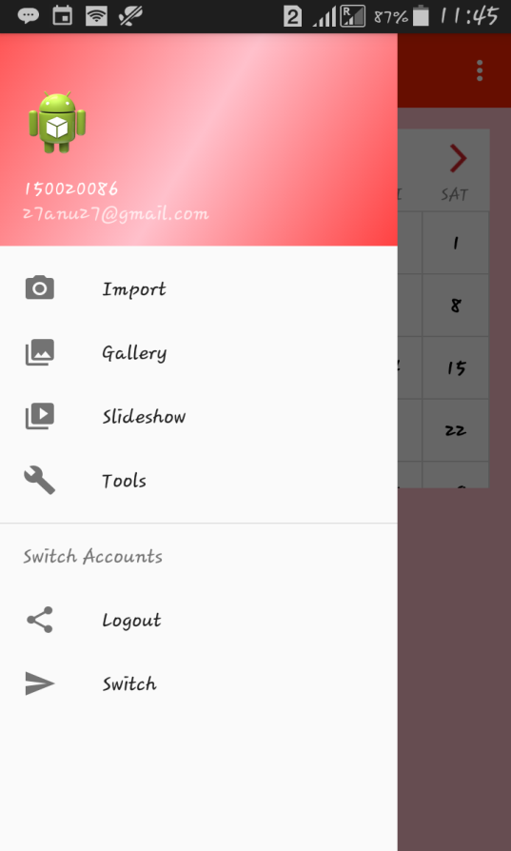

**ADMIN**

